### **Step-by-Step Guide: Running the Authorization Process**

**Understand OAuth 2.0 Flow:**

* [OAuth 2.0 is a protocol](https://developer.getjobber.com/docs/building_your_app/app_authorization/) that allows your app to request authorization to access a user’s Jobber data. This is done through a series of interactions between your app, Jobber, and the user.

**Generate the Authorization URL:**

* Construct the authorization URL that the user will visit to grant access. The URL should include the following components:

**Authorization Endpoint**: <https://api.getjobber.com/api/oauth/authorize>

**Client_id**: 80a216eb-bccd-4534-8578-570f718b6fb5

**Redirect_uri:** [**https://example.com/callback**](https://example.com/callback)

**Direct the User to the Authorization URL:**

* Present the authorization URL to the user (e.g., via a button or link in your app). When the user clicks this link, they will be redirected to Jobber’s authorization page.

Click here to start authorization the created app with your Jobber account:

<https://api.getjobber.com/api/oauth/authorize?response_type=code&client_id=80a216eb-bccd-4534-8578-570f718b6fb5&redirect_uri=https://example.com/callback&state=><STATE>

**User Grants or Denies Access:**

* **The user will be prompted to log in to Jobber (if they aren’t already) and then to grant or deny the requested permissions.**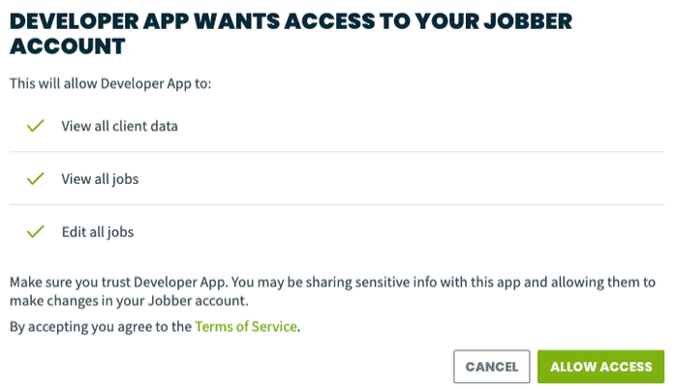
* **If the user grants access, they will be redirected to your specified redirect_uri with an authorization code appended to the URL.**

**Exchange the Authorization Code for an Access Token:**

**Send a POST request to Jobber’s token endpoint to exchange the authorization code for an access token and refresh token.**

* **Token Endpoint: https://api.getjobber.com/api/oauth/token**
* **Required Parameters:**
  + **client_id: Your app’s client ID.**
  + **client_secret: Your app’s client secret.**
  + **code: The authorization code received.**
  + **redirect_uri: The same redirect URI used in the authorization step.**
  + **grant_type: Set this to authorization_code**

**After AUTH Process:**

**You will prompted here, make sure to copy and paste the authorization_code**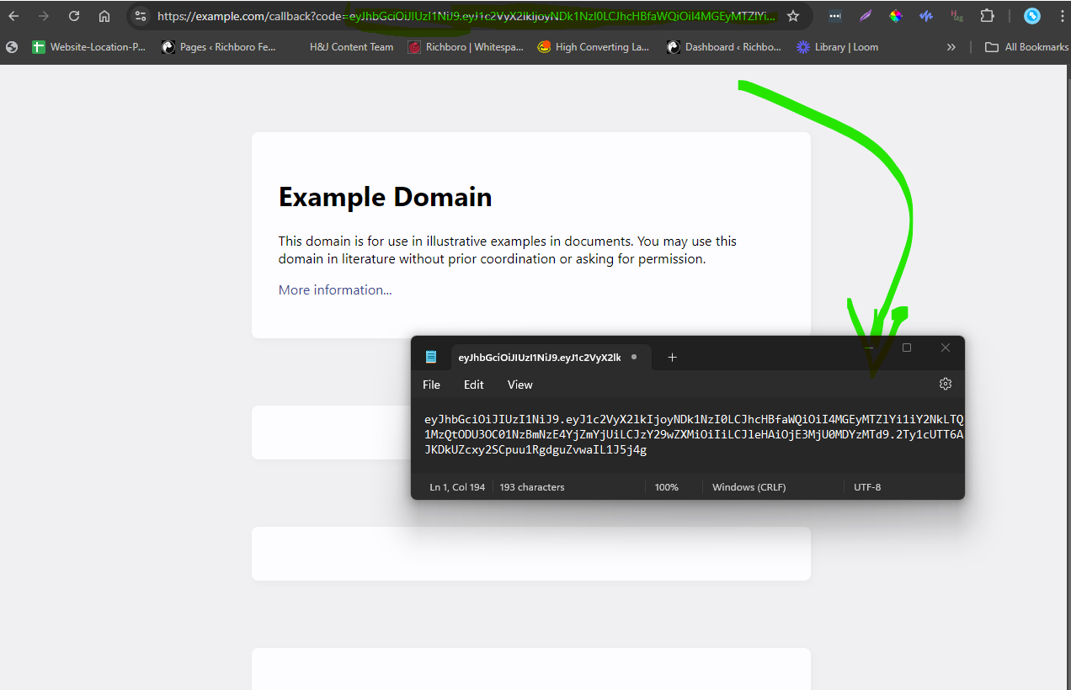

**SAVE THE CODE THAT STARTS HERE CODE=ey**